CO4 CASE STUDIES
Case study 1: India vs Australia Test — when should Captain Rohit Sharma declare? India is batting in the 2nd innings on Day 4 with a lead of 320 runs and 4 wickets in hand. Captain Sharma must decide: declare now (giving Australia 90 overs to chase 321) OR bat 1 more session (push lead to 380 but use up 30 overs, giving Aus only 60 overs to chase 381). Australia's 2nd-innings outcomes depend on overs available + pitch condition (worsening). Modelled as a game tree: India MAX node decides DECLARE/BAT-MORE; Australia MIN node decides ATTACK/DEFEND; chance node for pitch behaviour. India MAX (root) → Australia MIN (Aus picks attack/defend) → leaf utility (+1 win, 0 draw, −1 loss)
- Run minimax bottom-up. Leaves (left to right): 0.6, −0.2, 0.4, 0.0. Compute MIN values, then root MAX. State the value at every internal node and India's optimal action.
- Apply alpha-beta pruning with left-to-right traversal. Track α and β at each step. Identify any pruned subtrees. State how many leaves are visited (vs all 4 in pure minimax).
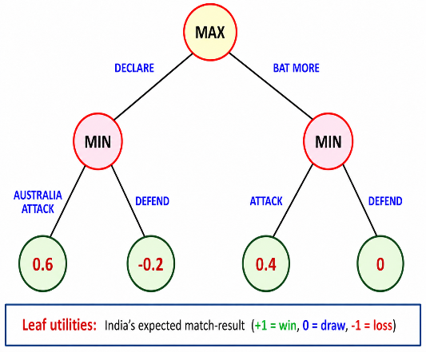

CASE STUDY 2: Diwali firework cracker stall safety-inspection — adversarial game between BBMP inspector and stall owner. During Diwali, BBMP fire-safety inspectors visit cracker stalls in Bengaluru. The stall owner may have hidden some unauthorised stock (more powerful crackers exceeding noise/explosive limits). The inspection is modelled as a 2-ply game: Inspector (MAX) chooses to inspect AISLE-1, AISLE-2, or AISLE-3; Stall owner (MIN) has pre-positioned stock to MINIMISE the inspector's expected fine-revenue. Leaf utilities are the inspection-payoff (₹ thousand): higher = inspector wins (more fines collected); lower = owner wins. Diwali stall inspection · MAX (inspector) → MIN (owner stock-positioning) → leaf utility (₹ K).
- Run minimax bottom-up on the tree above. Compute the MIN values for each AISLE branch: MIN(A1) = min(30, 12, 25) = ?, MIN(A2) = min(18, 40, 8) = ?, MIN(A3) = min(22, 15, 35) = ?. Then compute the root MAX value.
- Apply alpha-beta pruning with left-to-right depth-first traversal. Track α (best for MAX so far) and β (best for MIN so far) at each step. Identify which leaves are pruned. Boilerplate: start with α=−∞, β=+∞

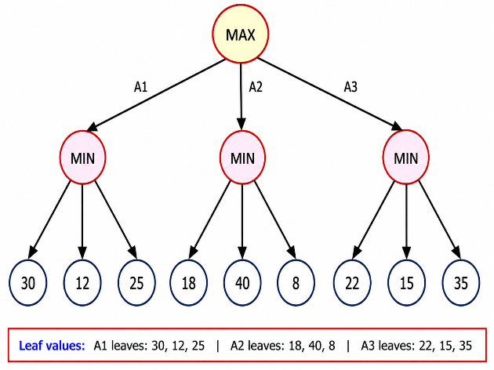
CASE STUDY 3:
Chess clock under time-pressure — minimax with bounded rationality. Two grandmasters play a Rapid format game (15 min + 10 sec increment). Player A has 3 minutes left; Player B has 2 minutes left. The position is complex: full minimax to depth 8 takes 5 minutes per player. Decisions must respect the clock. Players use iterative deepening + move-ordering. A 4-leaf minimax sub-tree is shown for the next decision: A (MAX) chooses move M1, M2, or M3; B (MIN) responds; resulting board-evaluations are the leaves.
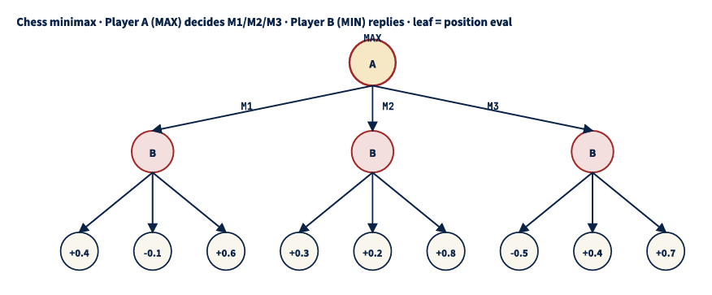
(a) Game-theoretic concepts. Define and contrast: (i) zero-sum game (one player's gain = other's loss; chess); (ii) perfect information game (all moves visible; chess) vs imperfect information (poker, Stratego)
(b) Bottom-up minimax. Compute MIN(M1) = min(+0.4, -0.1, +0.6) = ?; MIN(M2) = min(+0.3, +0.2, +0.8) = ?; MIN(M3) = min(-0.5, +0.4, +0.7) = ?. Compute root MAX = max of three MINs. State Player A's optimal move and the minimax value.
(c) Alpha-beta with left-to-right traversal. Identify which leaves are pruned. Show whether MIN(M3)'s subtree gets early-cutoff after seeing leaf -0.5. State leaves visited count vs full minimax (9).

CASE STUDY 4:
A self-driving car company is designing an AI system to safely navigate through city traffic. The AI uses the Expecti-minimax algorithm because traffic conditions involve both opponent actions and uncertain events. The AI car (MAX player) must decide between two routes to reach the destination:
Route A – Highway Route
Possible traffic conditions after selecting Route A:
Route B – City Route
Possible traffic conditions after selecting Route B:
Questions:
1. Identify the following nodes in the Expectiminimax game tree: MAX node , Chance node, Terminal nodes
2. Calculate the expected utility value of Route A & Route B. Which route will the AI select using the Expectiminimax algorithm?
ROUTE A
Traffic Condition | Probability | Utility Score
Smooth Traffic | 0.5 | 90
Moderate Traffic | 0.3 | 50
Heavy Traffic | 0.2 | 10

ROUTE B
Traffic Condition | Probability | Utility Score
Smooth Traffic | 0.3 | 80
Moderate Traffic | 0.4 | 60
Heavy Traffic | 0.3 | 40

Case study 5:
AIIMS oncologist decision tree — treatment selection under uncertainty. A patient at AIIMS Delhi has been diagnosed with Stage 2 lung cancer. The oncologist considers 3 treatments: S (surgery), C (chemotherapy), R (radiotherapy). Each has probabilistic outcomes for 5-year survival vs side-effects. Quality-of-life-adjusted utility (QALYs):
- S: 0.7 prob → 8 QALY ; 0.3 prob → 1 QALY (surgical complications, death)
- C: 0.5 prob → 6 QALY ; 0.5 prob → 3 QALY (chemo side-effects)
- R: 0.6 prob → 5 QALY ; 0.4 prob → 4 QALY (radiotherapy fatigue, lower variance)
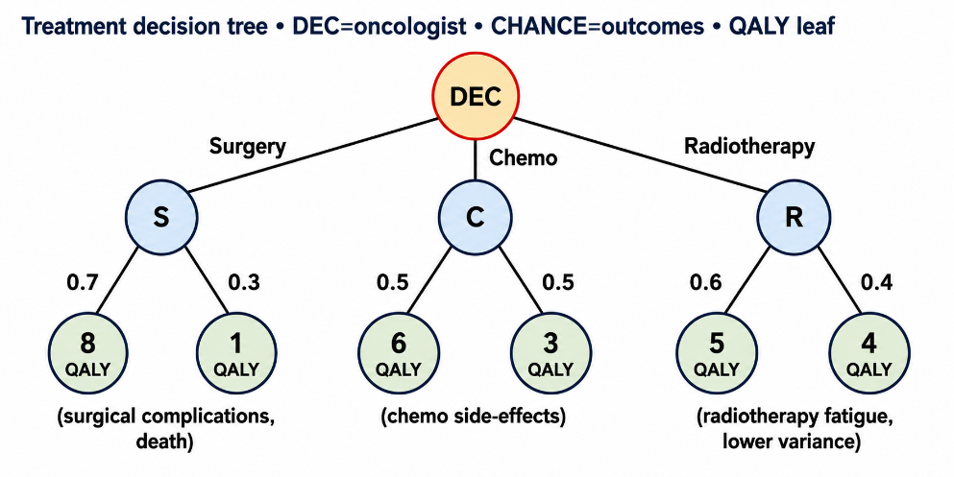
Questions
  - Using the treatment decision tree, compute the Expected QALY (utility) for each treatment option:
- Surgery (S)
- Chemotherapy (C)
- Radiotherapy (R)
Determine which treatment should be selected according to the Maximum Expected Utility (MEU) principle.

(b) Assume the oncologist is highly risk-averse and uses the Minimax criterion, considering only the worst possible outcome of each treatment and Compute:
$$max⁡\{min⁡(S),min⁡(C),min⁡(R)\}$$
$3.$Identify the treatment selected by the minimax strategy.
4.Write a Python program that:
- Stores probabilities and QALY values for S, C, and R.
- Computes the Expected Utility (Expected Minimax/Expectimax value) of each treatment.

